Organic Solar Cells Using Oligomer Acceptors for Improved Stability and Efficiency
Youcai Liang^{1,4}, Difei Zhang^{1,2,4}, Zerun Wu¹, Tao Jia¹, Larry Lüer², Haoran Tang¹, Ling Hong¹, Jiabin Zhang¹, Kai Zhang¹, Christoph J. Brabec^{2,3}, Ning Li^{1✉} & Fei Huang^{1✉}

The power conversion efficiencies of organic solar cells (OSCs) have reached over 19%. However, the combination of high efficiency and long-term stability is still a major conundrum of commercialization. Herein, a Y6-analogue and a 2,2'-bithiophene unit are utilized to construct a series of oligomer acceptors, in order to investigate the effect of molecular size and packing properties on photovoltaic performance. By altering the molecular chain length, we modify the thermal properties, crystallization behaviors and molecular packing and achieve an optimal microstructure and a more stable morphology in blend films. A combination of efficiencies over 15% and an extrapolated T₈₀ lifetime over 25000 h, which equates to an average lifetime exceeding 16 years in Guangzhou, is achieved for binary OSCs based on an oligomer acceptor. This work emphasizes the importance of oligomeric strategy in tuning molecular packing behaviors and blend morphology, leading to development of novel non-fullerene acceptors for stable and efficient OSCs.

¹State Key Laboratory of Luminescent Materials and Devices, Institute of Polymer Optoelectronic Materials and Devices, School of Materials Science and Engineering, South China University of Technology, Guangzhou, China. ²Friedrich-Alexander-Universität Erlangen-Nürnberg, Institute of Materials for Electronics and Energy Technology (i-MEET), Erlangen, Germany. ³Helmholtz-Institute Erlangen-Nürnberg for Renewable Energy (HI ERN), Forschungszentrum Jülich (FZJ), Erlangen, Germany. ⁴These authors contributed equally: Youcai Liang, Difei Zhang. ✉email: ningli2022@scut.edu.cn; msfhuang@scut.edu.cn

Introduction
Bulk-heterojunction (BHJ) organic solar cells (OSCs) have attracted considerable research interests owing to their promising advantages for decentralized photovoltaic applications, manifesting a great potential to complement the conventional solar technologies. In recent years, the power conversion efficiencies (PCEs) of OSCs are undergoing a revolution attributed to the rapid development of small molecule non-fullerene acceptors (SM-NFAs), which show advantages of infinite possibilities in molecular design, complementary absorption in near infra (NIR) region and suitable energy levels with polymer donors¹⁻³. Particularly, Y6 and its derivatives, emerging as one of the most significant breakthroughs in SM-NFAs, boosted the PCEs of single-junction OSCs to the level of 18%⁴⁻⁷. However, to realize commercial product and applications, the promising PCEs of OSCs should be accompanied with excellent stability values⁸⁻¹¹. Despite the fact that Y6 and its analogs are dominantly employed in OSCs with PCEs over 15%, the intrinsically low glass transition temperatures (T_{g}) and high diffusion properties of these Y-series SM-NFAs are prone to form kinetically unstable morphologies within the active layers of OSCs¹², being an elephant in the room as well as an obstacle to gain long-term stable devices.
To address the morphological instability of BHJ active layer, polymeric acceptors with high T_{g}s were developed for all polymer solar cells (APSCs), including N2200, P-BNBP-T and DCNBT-IDT, etc¹³⁻¹⁵. However, owing to either weak absorption coefficient in the NIR region or insufficient charge mobility, the efficiency of all-polymer OSCs was mainly limited to the level of ~11%¹⁶. One of simple but elegant strategies is to construct polymer acceptors by polymerizing SM-NFAs, which can inherit the advantages of precursor SM-NFAs, such as high extinction coefficients in the NIR region, considerably high electron mobilities, etc^{17,18}. Recently, great efforts have been devoted into the design and development of polymer acceptors based on polymerized Y-series SM-NFAs, by which thermal-stable morphology of photoactive layer could be achieved with PCEs of ~16%¹⁹⁻²¹.
Notwithstanding the above efforts, the processing of active layer for APSCs suffered a lot from the interchain entanglement of extending molecular chains, which is a major challenge to form ideal bicontinuous-interpenetrating networks within the active layer²². To optimize the PCE of APSCs, complicated consideration and precise regulation are required in preparation of active layer solution and processing condition²³⁻²⁵. It is worthwhile to note that the characteristics of polymer acceptors are in part dependent on the batches and molecular weights, which raises more uncertainty to APSCs device processing compared with systems based on SM-NFAs^{26,27}. Despite the fact that APSCs present much better stability under thermal stress or light illumination than OSCs based on SM-NFAs^{18,22}, the above problems of polymer acceptors do limit the development and commercialization of APSCs.
To circumvent the inherent problems of SM-NFAs and polymer acceptors simultaneously, development of novel materials with a high T_{g} as well as a certain chemical structure is of great necessity. In polymer physics, it is believed that extension of molecular chains leads to restraint on motion of molecular chains, especially oligomers with low molecular weights²⁸. Therefore, well-defined oligomers can also be expected to raise the T_{g}s of SM-NFAs and form stable morphologies in active layers, which determines the operational lifetime of OSCs.
Although researchers had reported OSCs with T₈₀s over 10,000 h, it is still challenging to construct OSCs combining the high efficiency with long lifetime that meet the demand of practical application⁸⁻¹¹. Inevitably, there has been some controversies with regard to whether high efficiency and long-term stability can be simultaneously achieved. To evaluate the feasibility of designing stable and efficient OSCs with oligomer acceptors and understand the structure-function relationship at molecular level, herein, an oligomeric strategy was proposed by a one-pot reaction with a Y6-analogue (OY1) as monomer and 2,2'-bithiophene as π-bridge unit. The resulting oligomer acceptors OY2, OY3 and OY4 presented ambiguous differences from their mother SM-NFA OY1 and the corresponding polymer acceptor (POY) in optical property and photovoltaic performance when using PBDB-T as electron donor, with the best PCEs ranging from 14.12% to 15.05%. However, distinct thermal properties, crystallization behaviors and molecular ordering were detected among those NFAs with different molecular chain lengths. Benefiting from precisely tuning the molecular size, OY3 combined adequate crystallinity that inherited from OY1 with thermal stability comparable to POY, leading to the optimized microstructure and stable morphology in corresponding blend films. Through photo-stability test, the OSCs retained over 90% of initial PCE after operating for over 1000 h with an extrapolated T₈₀ more than 25000 h, from which an average operational lifetime exceeding 16 years in Guangzhou could be excepted. This inspiring result offers a silver lining in the dark of unresolved conundrum of constructing stable and efficient OSCs.

Synthesis and characterization
The chemical structures and synthetic routes of oligomers and polymer are depicted in Fig 1a and Supplementary Fig. 1. Herein, 2,2'-((2Z,2'Z)-((12,13-bis(2-decyltetradecyl)-3,9-diundecyl-12,13-dihydro[1,2,5]thiadiazolo[3,4e]thieno[2'',3'':4',5']thieno[2',3':4,5]pyrrolo[3,2g]thieno[2',3':4,5]thieno[3,2-b]indole-2,10-diyl)bis(methanylylidene))bis(5-bromo-3-oxo-2,3-dihydro-1H-indene-2,1-diylidene))dimalononitrile was chosen as a copolymerization monomer (OY1). By introducing 5,5'-bis(trimethylstannyl)-2,2'-bithiophene (M1) as another comonomer, the corresponding polymer acceptor POY was synthesized via a Stille copolymerization with a weight-average molecular weight (M_{w}) of 19 kDa and a polydispersity index (PDI) of 2.2, according to the high-temperature gel permeation chromatography (GPC) results (Supplementary Fig. 2). The limited molecular weight of POY was consistent with Y-series polymer acceptors in previous study^{20,29}, which was probably due to the steric bulk of Y-derivative molecules, especially for γ-functionalized dibromo monomers³⁰⁻³². Compared to polymerization reaction, the reaction for preparing oligomers was conducted under a milder condition and monitored by thin layer chromatography (TLC) (Supplementary Fig. 3), so that excessive molecular chain growth can be depressed to obtain oligomers with several repeating units³³. The oligomers with different numbers of Y-series building block, refer to as OY2, OY3 and OY4, were separated and purified by column chromatography as single molecular entities. The chemical structures of OY2-OY4 were confirmed by matrix assisted laser desorption ionization time of flight mass spectrometry (MALDI-TOF MS) (Supplementary Fig. 4-7) and high-temperature nuclear magnetic resonance (NMR) spectroscopy (Fig. 1b, Supplementary Fig. 8-14). For OY1, the chemical shifts of 4 protons on aromatic ring and vinyl group within single IC moiety were characterized at 9.20, 8.57, 8.07 and 7.88 ppm, respectively. After extending the molecular chain as OY3, the chemical shift of each aromatic proton showed distinct change and divided into three proton peaks, while peaks located from 7.2 to 7.6 ppm were assigned to protons of bithiophene unit. As for OY4 and POY, the proton peaks turned obscure and overlapped owing to the intrinsically long molecular chains and strong aggregation properties.
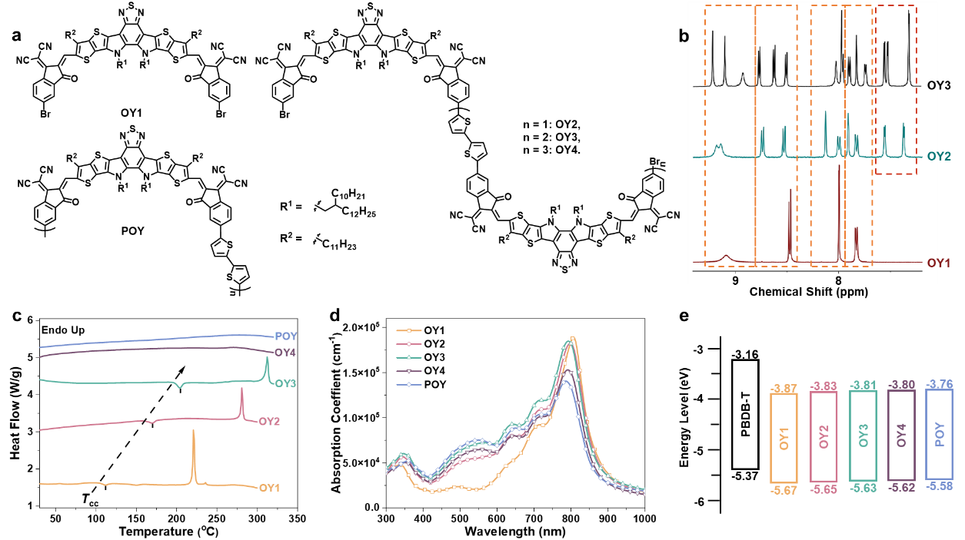
Fig. 1. Material characterizations of acceptors. a Chemical structure of OY1-OY4 and POY, b ¹H NMR spectra of aromatic protons within OY1-OY3, c First heating DSC curves of 5 acceptors, d UV−vis absorption spectra of 5 acceptors in solid states, e Energy level diagram of 5 acceptors, the HOMO and LUMO energy levels of 5 acceptors were estimated from the CV curves.

The effect of molecular weight/size on thermal property of materials was investigated by conducting thermogravimetric analyses (TGA) (Supplementary Fig. 15) and differential scanning calorimetry (DSC) (Fig. 1c) measurements. With increasing the molecular size, oligomer acceptors and polymer acceptor exhibited higher thermal stability with 5%-weight-loss temperature scaling from 320.0 ℃ to 357.9 ℃. OY1 exhibited a cold crystallization peak at 111 °C and a melting temperature (T_{m}) at 220 °C in the first heating scan, which is comparable to that of Y6⁷. With increasing the molecular size, both cold crystallization temperature (T_{cc}) and T_{m} were increased for OY2 and OY3. However, no obvious cold crystallization or melting peak was detected for OY4 and POY below 320 ℃, indicating that the morphology of both materials is amorphous dominated¹⁸. The correlated DSC data are listed in Supplementary Table 1 and cold crystallization peak of OY2 and OY3 was located at 170 ℃ and 204 ℃, respectively. It has been suggested that the T_{cc} of SM-NFAs could be a critical parameter predicting morphological stability³⁴⁻³⁷. Compared to OY1, both OY2 and OY3 exhibit a much higher T_{cc} and a more distinct crystallization peak, which is beneficial for the formation of stable microstructure morphology. Although no clear melting or crystallization peak was detected for OY4 and POY, better thermal stability of OY4 and POY can also be expected because of their longer molecular chains²⁸.
The optical properties of OY1-OY4 and POY in chloroform and in solid-film state were investigated by UV-vis absorption spectroscopy (Fig. 1d and Supplementary Fig. 16). In solution state, the extinction coefficients of acceptors decrease with increasing chain lengths, attributing the introduction of twisted bithiophene units that lead to reduced persistence lengths³⁸. After spin-coated into films, the absorption peaks (λ_{max}) of OY1-OY4 and POY all distinctly red-shifted and located at almost the same wavelength, ranging from 780 nm to 795nm, the specific parameters are summarized in Supplementary Table 2. Interestingly, OY2-OY4 and POY all presented a pronounced π-π* transition peak located at ~500 nm, attributing to the well-delocalized LUMOs that extended to the π-bridge bithiophene unit because of the γ-linking site on IC moiety^{30,31}, as proven by the DFT results (Supplementary Fig. 17).
According to the cyclic voltammetry (CV) curves (Supplementary Fig. 18), the highest occupied molecular orbital (HOMO) and lowest unoccupied molecular orbital (LUMO) energy levels of these materials were estimated. From OY1 to POY, the E_{HOMO} and E_{LUMO} raised from -5.67 to -5.58 eV and -3.87 to -3.76 eV, respectively, suggesting that the introduction of bithiophene units lifted both E_{HOMO} and E_{LUMO} to a limited extent (Fig. 1e).

Device performance and morphology investigation.
OSCs based on OY1-OY4 and POY were fabricated and characterized with a conventional device structure of ITO/PEDOT:PSS/Active Layer/NDI-Br/Ag, in which PBDB-T was selected as the electron donor because of its well-matched energy level with these acceptors. According to the previous work, the OSCs were optimized by using chloroform with 1% 1-chloronaphthalene (1-CN)³⁰. The optimization procedures of PBDB-T:OY3 are detailed in Supplementary Table 3-6. The statistics of photovoltaic parameters are summarized in Table 1. It was found that varying the processing conditions led to similar device performance. As shown in Fig. 2a, OSCs based on different acceptors exhibited comparable photovoltaic characteristics with the best PCEs ranging from 14.12% to 15.05%, suggesting the excellent reproducibility of acceptors based on OY1 and its derivatives. Compared with OY1, increased J_{SC} values for OY2-OY4 and POY were found, correlating well with the J_{SC} values integrated from external quantum efficiency (EQE) spectra (Fig. 2b). Fig. 2c shows the PCE distribution for these acceptors, suggesting that molecular weight has little influence on the performance of OSCs. In addition, inverted OSCs based on OY1-OY4 and POY were also fabricated (Supplementary Fig. 22 and Supplementary Table 7), from which close PCEs and similar trends to the conventional devices were presented.
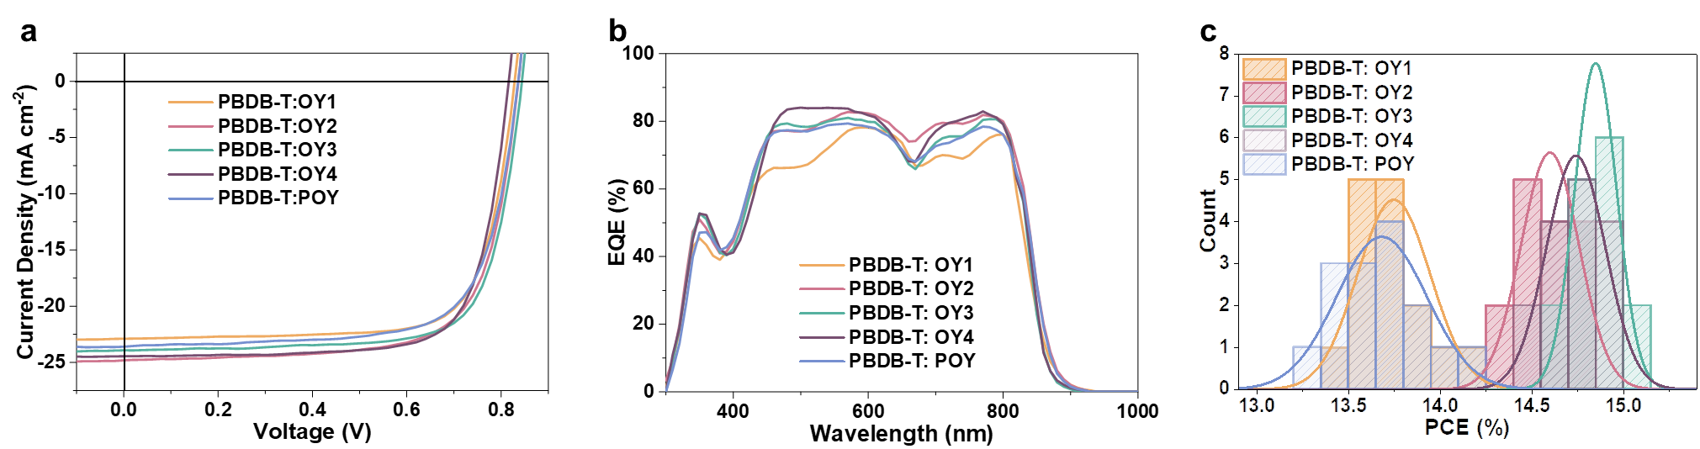
Fig. 2. Device performance of OY1-OY4 and POY. a J–V characteristics and b EQE spectra of the optimized OSCs measured under AM 1.5 G illumination (100 mWcm⁻²), c histogram of PCE values for OSCs based on different acceptors, fitted with Gaussian distributions (solid lines).

Table 1. Average OSC performance parameters for conventional devices based on different acceptors blended with PBDB-T under the optimized conditions.
Acceptor | V_{OC} (V) | J_{SC} (mA cm⁻²) | J_{EQE}^{a)} (mA cm⁻²) | FF (%) | PCE^{b)} (%)
OY1 | 0.823±0.010 | 22.59±0.35 | 21.26±0.46 | 74.00±0.85 | 13.75±0.20(14.20)
OY2 | 0.839±0.004 | 24.26±0.34 | 22.90±0.15 | 71.68±0.68 | 14.60±0.16(14.82)
OY3 | 0.839±0.003 | 23.76±0.25 | 22.42±0.20 | 74.58±0.70 | 14.87±0.11(15.05)
OY4 | 0.814±0.002 | 24.39±0.09 | 22.93±0.09 | 74.69±0.38 | 14.82±0.10(14.97)
POY | 0.833±0.005 | 23.45±0.41 | 22.26±0.12 | 70.58±1.37 | 13.79±0.21(14.12)
a) Calculated from EQE measurements. b) The best PCEs are provided in parenthesis.

As shown in Supplementary Table 8, both OY3- and OY4-based BHJ blends had high and balanced charge mobilities, with hole/electron mobilities of 19.80 $×$ 10⁻⁴/16.80 $×$ 10⁻⁴ (μ_{h}/μ_{e} =1.18) and 18.10 $×$ 10⁻⁴ /14.00 $×$ 10⁻⁴ (μ_{h}/μ_{e} = 1.29) cm² V⁻¹ s⁻¹, respectively, contributing to the corresponding OSCs with efficient charge extraction and FFs reaching 75%. Furthermore, charge recombination behaviors of different acceptors were also compared by analyzing the light intensity (P_{light}) dependance of V_{OC} and J_{SC} (Supplementary Fig. 28), suggesting that OY1 and POY presented stronger trend of trap-assisted monomolecular recombination than OY2-OY4. Moreover, no clear correlation was found for these oligomer acceptors between molecular weights and recombination behavior.
Two-dimensional (2D) grazing-incident wide-angle X-ray scattering (GIWAXS) measurements were performed to analyze the microstructures and molecular packing behaviors of neat films. The corresponding 2D patterns and one-dimensional (1D) line-cut profiles are depicted in Fig. 3a-3b and Supplementary Fig. 29. From the 2D pattern, the OY1 pristine film revealed multiple stacking peaks (010) along the in-plane (IP) direction with a dominant out-of-plane (OOP) lamellar peak (100) at q=0.284 Å⁻¹, indicating that OY1 molecules exhibited a preferentially edge-on orientation and high crystallinity. Interestingly, those scattering peaks in the OOP direction disappeared after extending the molecular chain length, because the planarity and the highly-ordered packing feature of OY1 molecule was interrupted by the flexible π-bridge¹⁸. OY2-OY4 and POY all had a distinct OOP (010) peak with an “arc” shape IP (100) diffraction pattern, corresponding to face-on orientation in film states. With increasing the repeating unit numbers from OY1 to POY, the location of π-π stacking diffraction peak was gradually shifted to high q values, indicating a closer π-π d-spacing from 4.14 to 3.75 Å and a more intense π-π stacking feature. The crystal coherence lengths (CCLs) of (010) orientation were estimated according to Scherrer equation, as summarized in Supplementary Table 9. Despite the most intense OOP π-π stacking characteristic, POY presented a broader OOP (010) diffraction peak than OY1 and OY2-OY4 with a CCL of 1.05 nm. Notably, OY3 exhibited a strong OOP π-π stacking diffraction peak with a corresponding CCL of 1.51 nm, higher than that of OY2 (1.19 nm) and OY4 (1.28 nm). The strongest OOP (010) crystallinity of OY3 among these OY2-OY4 and POY is in favor of the charge transport along the vertical direction within the active layer.
It is worth mentioning that the number of repeating unit for POY is only 5~10, which is consistent with Y-series polymer acceptors in previous study^{20,29,31,32}. OY4 has a molecular weight between the oligo-to-polymeric transition, leading to the similarity between OY4 and POY as ¹H NMR and DSC data shown above. In addition to stronger crystallinity, OY3 also possessed better thermal property than OY2 as discussed before. Therefore, OY3 was chosen as a representative of oligomer acceptors to compare with OY1 and POY in the following sections.
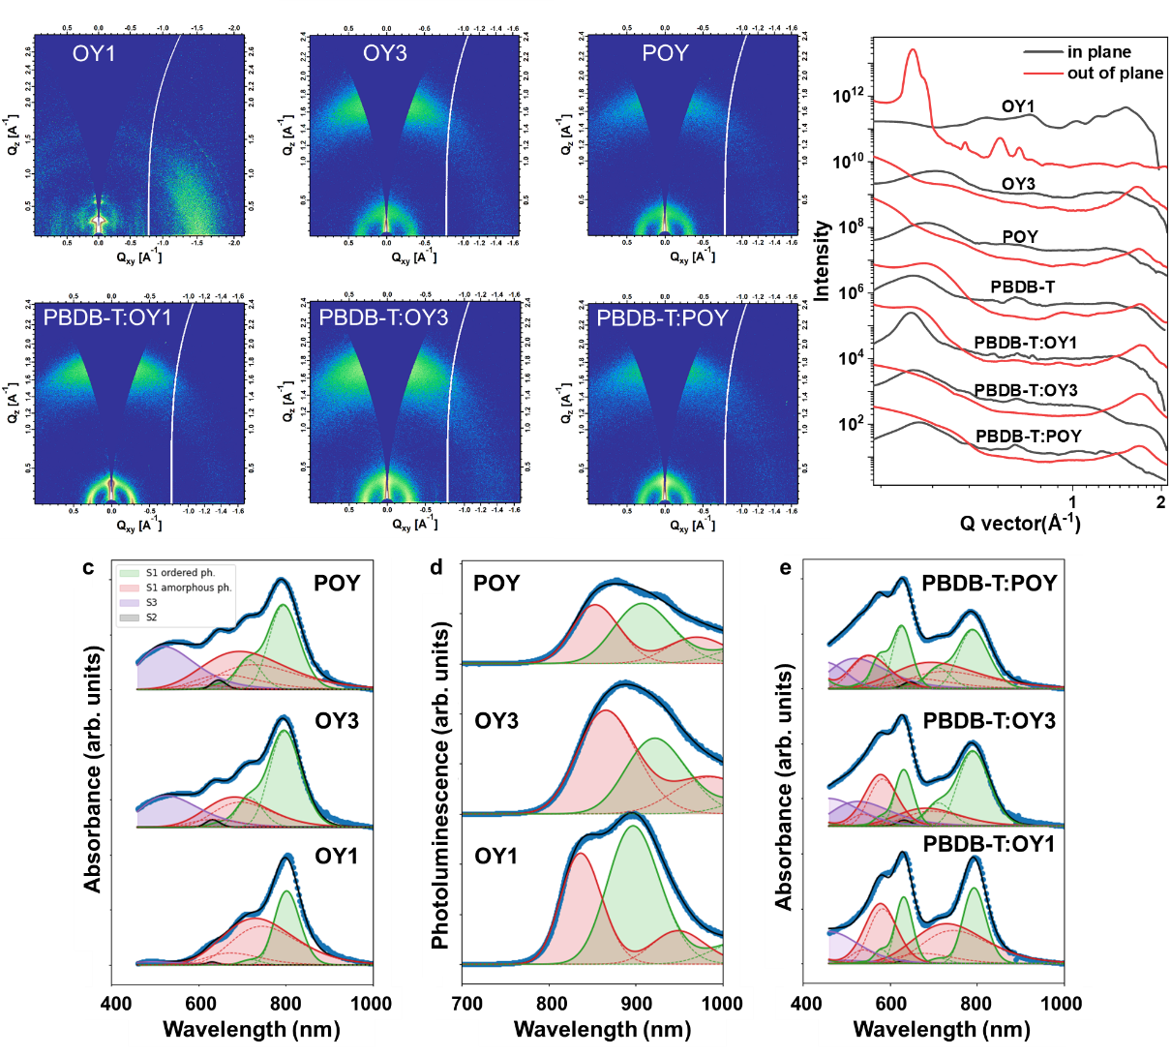
Fig. 3 Molecular packing behaviors and photophysical properties of OY1, OY3 and POY. a 2DGIWAXS patterns and b 1D line-cut profiles of OY1, OY3, POY neat films and corresponding blend films, c absorption profiles and d PL profiles of OY1, OY3 and POY neat films, e absorption profiles of corresponding blend films with PBDB-T. Blue symbols: experiment results; shaded areas: contributions of S0-S1 electronic transition from ordered and amorphous phase (green and red, respectively), from S0-S2 and S0-S3 transitions (gray and purple, respectively), as resulting from spectral modeling (Methods for details). Dashed lines indicate vibronic sub-bands. For Fig. 3e, the relative spectral weights of the acceptor phase were fixed to those observed in Fig. 3c, to avoid overfitting.

The morphology of BHJ blend films was further characterized. It was found that all the blend films presented distinct face-on orientation with announced OOP (010) diffraction peaks and IP (100) peaks, indicating ordered microstructures. The OOP (010) peak of PBDB-T:OY1 blend film mainly originated from the PBDB-T (010) diffraction, while the IP (100) diffraction peak became sharper in PBDB-T:OY1 blend film, suggesting that OY1 molecules enhanced the IP lamellar orientation of PBDB-T. Concerning PBDB-T:OY3 blend film, the diffraction signal basically came from PBDB-T, demonstrating the well-mixed morphology of PBDB-T:OY3 blend. Surprisingly, PBDB-T:POY blend film had a diffraction feature dominated by the OOP (010) diffraction of POY instead of PBDB-T, with a d spacing of 3.75 Å and CCL of 1.00 nm. The absence of PBDB-T diffraction signal indicates that the crystalline behavior and π-π stacking orientation of PBDB-T was severely disturbed after blending with POY, probably due to the strong disorder from the wide molecular weight distribution of POY.
To further understand the morphologies of blend films, Flory-Huggins interaction parameters (χ) were estimated from the introduction of surface energy (γ), according to the equation: $χ_{DA}={K(\sqrt{γ_{D}}-\sqrt{γ_{A}})}^{2}$, while K is a constant, D and A is refer to donor and acceptor, respectively. The surface energy values of pure films were acquired from the contact-angle measurements (Supplementary Fig. 30 and Supplementary Table 11), from which the χ parameters were calculated as 0.20, 0.03 and 0.03 for PBDB-T:OY1, PBDB-T:OY3 and PBDB-T:POY, respectively. A low χ parameters is indicative of hyper-miscibility between two components, and vice versa. It is evident that OY1 is hypo-miscible with PBDB-T, while OY3 and POY both have good miscibility with PBDB-T, leading to the well-formed morphology of PBDB-T:OY3 blend film. Although OY3 and POY share the similar miscibility with PBDB-T, the discrepancy in morphology between PBDB-T:OY3 and PBDB-T:POY blend film reveals that the microstructure is determined not only by the miscibility of two components, but by the molecular packing features of acceptors.
In addition to scattering technics, optical absorption and emission spectra yield additional information about the degree of ordering in the solid state^{39,40}. As shown in Fig. 3c, the absorption profile of OY1, OY3 and POY are characterized by a main maximum at ~800 nm, followed by shoulder peaks at ~710, ~640, and ~550 nm. The peak at ~800 nm and ~710 nm is assigned to the S0 →S1 electronic transition with partial charge transfer (CT) character and its first vibronic (0-1) sideband, respectively (green shaded band). Transient absorption data in structurally related systems also confirm the presence of two similar absorption features, while those relative strength depends on the excitation energy^{41,42}. Following Kasha’s rule, the observation of such an excitation memory points to the presence of an amorphous phase, whose absorption is blue-shifted and broadened with respect to the ordered phase (shown as red shaded areas in Fig. 3). The band at ~640 nm is not a further vibronic sideband but rather a separate, weakly allowed electronic transition⁴³. Finally, the broad band around 550 nm is associated with a π-π* transition as discussed above^{30,31}. After being excited with a 473-nm laser, the corresponding photoluminescence (PL) spectra were obtained. As shown in Fig. 3d, the peaks have an opposite position to absorption and thus can be modeled by a superposition of two separate vibronic progressions with their respective (0-0) transitions around 820 and 900 nm (red and green shaded areas), respectively. The absorption profiles of blend films are depicted in Fig. 3e. After blending with PBDB-T, the prolonged chain length of acceptor also affected the molecular orientation of PBDB-T, resulting in a decreased ratio of ordered phase to amorphous phase from PBDB-T:OY1 to PBDB-T:POY blend film, which explained well the distinct morphological characteristic of PBDB-T:POY blend film from the GIWAXS measurements.
Above all, OY3 exhibited adequate crystallinity and good miscibility with PBDB-T, leading PBDB-T:OY3 blend films to a well-mixed morphology with properly oriented microstructure. In contrast, OY1-based blend film suffered from the intense crystallization tendency of OY1 and weak miscibility between PBDB-T and OY1, while strong disorder of POY impeded the crystallization and orientation of PBDB-T. It is reasonable to infer that OY3 not only succeeds in combing the advantages of OY1 and POY, but also overcomes their inherent problems.

Stability of OSCs
Since OY3 inherits the advantages of its reference polymer acceptors, such as thermal properties and face-on packing feature, it is reasonable to anticipate that OY3 could achieve comparable thermal stability to POY. The thermal stability of the BHJ films were evaluated by annealing at 150 ℃ for 180 min, which is almost the harshest condition to evaluate the thermal stability of OSCs^{18,44}. AFM measurements were conducted to compare the changes in top surface morphology of active layers after heating. As depicted in Fig. 4a, the optimized PBDB-T:OY1, PBDB-T:OY3 and PBDB-T:POY blend films had a root mean square (RMS) roughness value of 3.78, 1.69 and 1.66 nm, respectively. After thermal annealing at 150 ℃ for 180 min, severe phase separation via Ostwald ripening was identified for the PBDB-T:OY1 blend film, with the RMS roughness value increased to 26.8 nm. Blend films based on OY3 and POY remained almost unchanged under thermal stress. The thermal induced OY1 molecular diffusion and aggregation in mixed phase, resulting in the growth of OY1 crystal and leading to harsh phase separation³⁶. The much higher T_{cc} of OY3 and POY can prevent the large phase separation in the blend films upon thermal aging³⁵.
As shown in Supplementary Fig. 31 and Supplementary Table 12, OSCs based on PBDB-T:OY1 showed a severe decrease in performance after thermal annealing, with PCE remaining 77% of the optimal device. In the case of OY3-based and POY-based blend films, OSCs presented promising thermal stability and maintained the PCE values to level of ~12.8%. These results suggest that OY3 not only inherits the optoelectronic properties of OY1, but also has a comparable thermal stability to POY, identifying the important role of extending conjugated backbone in enhancing morphological stability against thermal stress^{45,46}.
Multiple strategies have been developed to improve the operational stability of OSCs, including molecular design of SM-NFAs, introducing a third component into active layer, and interface engineering of devices^{47,48}. However, it is still challenging to construct a donor-acceptor pair with simultaneously high efficiency and long-term stability⁹. For systems based on SM-NFAs, most of OSCs with PCEs over 15% were fabricated by employing Y-series small molecules as electron acceptors, which would contribute to inherently unstable morphology in active layer¹². Although several works reported that Y-series polymer acceptors had better stability than the relevant SM-NFA precursors, the delineation of APSCs’ intrinsic degradation mechanism is rather challenging due to the complicated interaction between polymer donors and polymer acceptors originated from the wide molecular weight distribution, especially under illumination stress, which limits the practical applications of polymer acceptors^{18,22,49}. On the basis that OY3 is capable of combining the merits of OY1 and POY with a well-defined chemical structure, a high T_{cc} as well as appropriate crystallinity, it is plausible to anticipate that OY3-based OSCs can achieve both high efficiency and long lifetime^{12,35,37}. Therefore, the photo-stability of OSCs based on these acceptors was characterized and the structure-function relationship was investigated. Inverted OSCs of ITO/ZnO/active layer/MoO_{x}/Ag were adopted for the photo-stability test, so that negative effect of organic interlayers on device stability would be minimized^{50,51}. Fig. 4b depicts the change in photovoltaic parameters of devices under continuous one-sun-equivalent illumination in nitrogen atmosphere. It is notable that after 200-hour photo-aging OSCs based on all the acceptors maintained over 80% of their initial efficiencies.
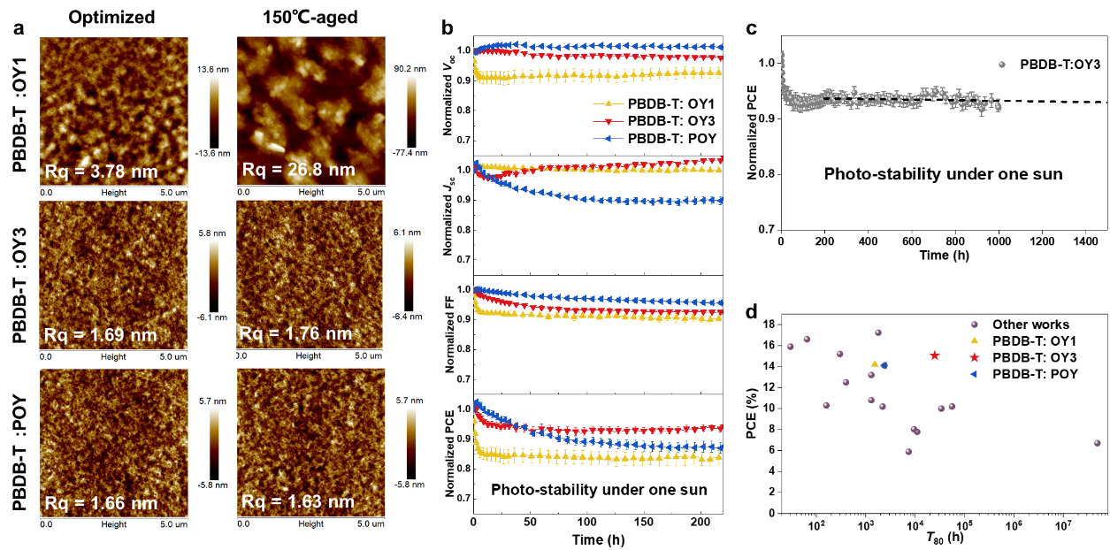
Fig. 4. Thermal stability and photo-stability of OSCs. a AFM height images of blend films processed under optimal condition or 150 ℃ heat stress for 180 min, b the change in J_{sc}, V_{oc}, FF and PCE of OSCs under continuous illumination in a dry nitrogen atmosphere, c PCE in the course of 1000 hours light exposure in N₂ atmosphere of PBDB-T: OY3, d PCEs and photo-stabilities of OSCs from previous studies and this work. All the light-degradation data were achieved by over 10 devices, while the error bars correspond to the standard deviation.

OSCs based on OY1 exhibited a fast burn-in loss, remaining about 84% of initial PCE values with decay in V_{oc} and FF. It has been reported that annealing protocols would lead to nucleation and crystallization of SM-NFAs if annealing temperature reaches T_{cc} or T_{g}^{35,36}. As discussed above, the low T_{cc} of OY1 increased the propensity to crystallization or agglomeration for amorphous OY1 molecules within mixed phase during device operation, resulting in unfavorable phase separation⁵². The excessive aggregation of OY1 could form low energy region, and the rearrangement of molecular packing could cause excessive phase separation along with unfavorable interface contact, being mainly responsible for the degradation of V_{OC} and FF³⁵. In the meantime, the diffusion of amorphous OY1 molecules also led to decreased volume fraction of OY1 within PBDB-T matrix that below the percolation threshold, bringing about decline in charge transport properties and drop in FF^{53,54}. Additionally, the potential degradation induced by interface layers and change in nanostructure cannot be ruled out^{50,51,55}, either.
In the case of polymer acceptors, OSCs based on POY retained about 87% of initial PCE after operating over 200 h with a long-term degradation of J_{SC}, while V_{oc} were steady and FF slightly decreased, showing an entirely different degradation mechanism from OY1. It is necessary to point out that, there were few studies focusing on photo-stability of APSCs, especially the inner mechanism of J_{SC}-dominated degradation in this work, which differed essentially from the previously reported results of APSCs⁵⁶.In addition, the degradation behavior of APSC is structure-dependent and the complicated interaction between polymer chains with wide molecular weight distribution also brings more difficulty in investigating the intrinsic degradation mechanism⁴⁹, while more efforts are required to give deeper understanding to the problem.
Interestingly, OY3 presented outstanding photo-stability, maintaining 94% of initial PCE after operating for 200 h. As seen in Fig. 4b, OY3 had V_{OC} and FF decays between OY1 and POY after light aging, while J_{SC} remained unchanged like most of stable system based on SM-NFAs^{10,57,58}. Therefore, it can be speculated that OY3 presents an SM-NFA-type degradation mechanism. Ultimately, the photo-stability of OY3-based OSCs was further conducted for over 1000 h and the device performance remained almost unchanged after the initial burn-in degradation, that probably attributed to the synergistic effect of local molecular reorganization of OY3 and the penetration of carrier transport layers and electrode into active layer^{36,55,57}. As depicted in Fig. 4c, the extrapolation of operational stability of PBDB-T:OY3 indicates an average T₈₀ lifetime of more than 25000 h (over 16 years if operating average 1500 h per years in Guangzhou)¹¹, which is significantly higher than that of OY1 (T₈₀=1535 h) and POY (T₈₀=2385 h) evaluated under the same condition. Conspicuously, the extraordinary stability of OY3-based device is able to meet the requirement of commercialization^{11,59}, which is also the first binary OSC that can simultaneously present a PCE over 15% as well as a T₈₀ over 25000 h (Fig. 4d).
In order to analyze the difference in photo-stability between SM-NFA and oligomer acceptor, the diffusion coefficients (D) of OY1 and OY3 were estimated, which is crucial for microstructure stability. Despite of a thermodynamically unstable system, the morphology could be kinetically stabilized only if the diffusion coefficient is sufficiently low at a specific temperature³⁷.
According to literature, for PBDB-T-based system the relation between diffusion coefficient at 85 ℃ (D₈₅) and T_{g} of SM-NFA was fitted³⁷:
$$D_{85}=1.2×{10}^{7}e^{-0.15T_{g}}$$
Here, T_{cc} can be substituted for T_{g}, which is 384 K and 477 K for OY1 and OY3, respectively. Thus, the D₈₅ of PBDB-T:OY1 and PBDB-T:OY3 is 7.6$×$10⁻¹⁸ and 1.0$×$10⁻²³ cm² S⁻¹, respectively. Apparently, the enhancement in operational stability can be interpreted as a result of the much higher T_{cc} of OY3 and also a 5-order of magnitude lower D₈₅ of PBDB-T:OY3. It should be noted that a diffusion coefficient of 1.0$×$10⁻²² cm² S⁻¹ is commonly regarded as the threshold to a kinetically stable system, equivalent to a diffusion distance of 20 nm in 10 years³⁵. The D₈₅ of PBDB-T:OY3 is even 1-order of magnitude lower than the kinetically stable threshold (Supplementary Fig. 33), demonstrating the effectiveness of oligomeric acceptor strategy in suppressing diffusion property of SM-NFAs.
Fig. 5 depicts schematic diagram of morphology evolution for OY1, OY3 and POY-based active layers. The transmission electron microscopy (TEM) images in Supplementary Fig. 34 show well-mixed morphologies for all blend films. The strong diffusion property of OY1 motivated amorphous OY1 molecules to eject from the PBDB-T matrix and reorganize, resulting to unfavorable phase separation in active layer. For OY3, the much higher T_{g}/T_{cc} endowed OY3 with such a low diffusion coefficient within PBDB-T matrix that OY3 only nucleated locally and the optimal morphology of PBDB-T:OY3 could be locked during operation. The disorder of POY came from the wide molecular weight distribution and high molecular weight resulted to the disturbance of crystallinity and orientation of PBDB-T in blend films, which might be one of the causes for the degradation of J_{sc} in POY-based OSCs.
In the case of oligomer acceptor, OY3 solved the critical molecular design conundrum that how to simultaneously achieve high performance, intrinsic stability and reproducibility. On the one hand, OY3 possesses the advantages of polymer acceptors with considerable thermal stability as well as sufficiently low diffusion property, and succeeds in achieving a photostable morphology and breaking the stability bottleneck of Y-series SM-NFAs¹². On the other hand, OY3 inherits partly the characteristics of OY1 with appropriate crystallinity and a well-defined chemical structure, thus overcoming the low batch-to-batch reproducibility shortage of polymer acceptors³³. Ultimately, the OY3-based OSC, with a PCE over 15% and an extrapolated lifetime over 16 years, indisputably brings the development of OSCs to a practical application level and offers molecular designs of materials for OSCs a novel perspective. The chain length effects of the acceptors on PCE and stability of the OSCs were also investigated with another model polymer PM6 (Supplementary Table 13). PM6:OY3 delivered the highest PCE among these acceptors, which is consistent with the trend observed for OSCs based on PBDB-T (Supplementary Fig. 35 and Supplementary Fig. 36). In addition, the PM6:OY3 averagely maintained 95% of initial PCE after illuminating for 300 hours, further proving the effectiveness of oligomeric strategy in improving photo-stability of NFA-based OSCs (Supplementary Fig. 37). It should be mentioned that interfacial engineering is also an effective strategy to enhance both efficiency and stability of OSCs^{8,11}. Thus, we are optimistic that the strategy developed in this work can further promote OSCs with excellent performance and stability by combining other optimization concepts.
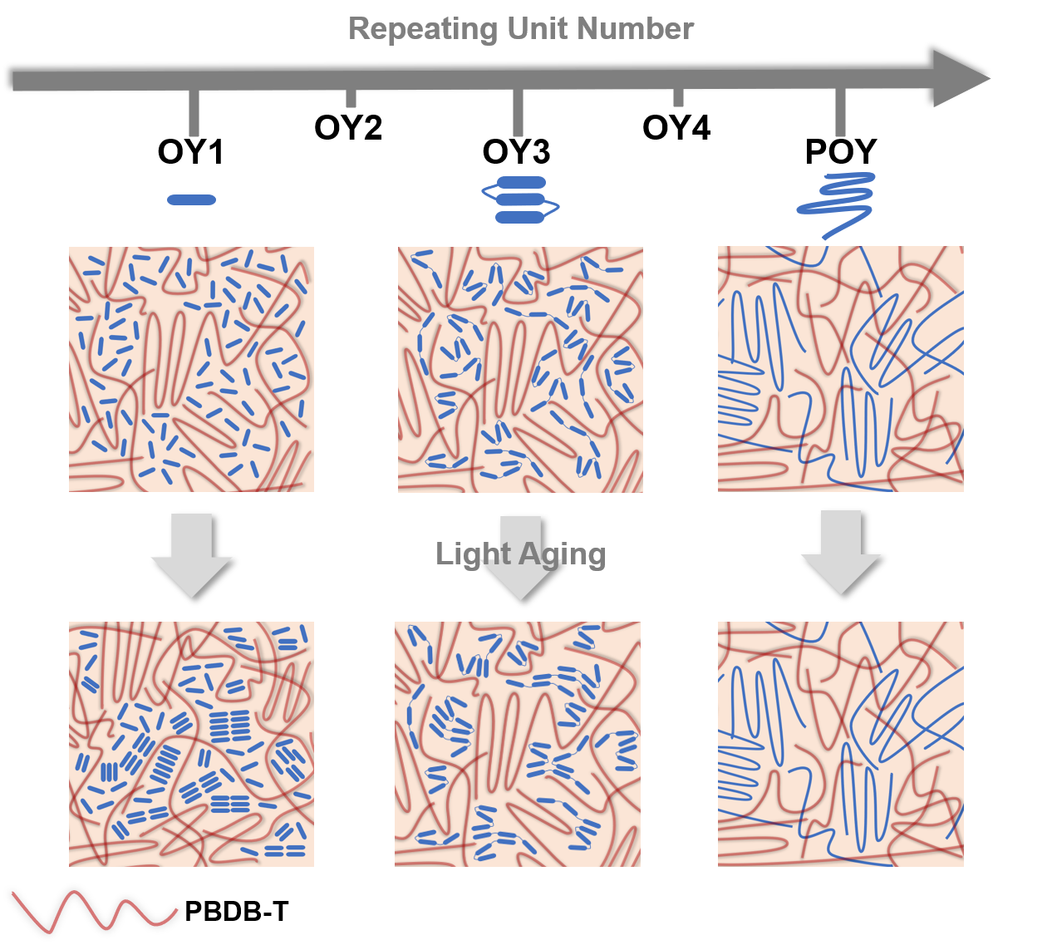Fig. 5. Advantages of OY3. Schematic diagram of morphology evolution in blends based on OY1, OY3 or POY under light soaking, respectively.

Conclusion
In this study, we have systematically investigated the influence of repeating unit numbers on NFAs. Despite the little effect on optoelectronic properties and PCE values, the distinctions in thermal property, crystalline behaviors and structural order were tracked. Combining the advantages of OY1 and POY, OY3 showed a high T_{cc} of 204 ℃ with adequate crystallinity and improved π-π stacking feature that benefited to form the optimized microstructure and stable morphology. The OSCs based on OY3 yielded PCEs exceeding 15% and extraordinary photo-stability, maintaining surpassing 90% of the initial efficiency after light-aging for 1000 h. An average T₈₀ lifetime exceeding 25000 h was extrapolated, which is equivalent to an operating lifetime over 16 years in terms of an estimated solar illumination of 1500 kWh/(m² year) for Guangzhou, China. This is the first binary single-junction OSC that combines the PCE of 15% with a commercially available T₈₀ lifetime simultaneously. We believe such an oligomeric strategy could provide innovative insight into molecular design and bring the organic photovoltaic technology closer to practical application.

Methods
Materials. Polymer donor PBDB-T and PM6 was purchased from commercial sources (Solarmer Materials Inc.) and used without further purification. The reagents and solvents were purchased from commercial sources and used as received unless otherwise noted.

Materials synthesis. The detailed synthetic procedures of OY1 are described in the Supplementary Fig 1.
Preparation of OY2, OY3 and OY4. Compound OY1 (596.6 mg, 0.30 mmol), 5,5'-bis(trimethylstannyl)-2,2'-bithiophene (M1) (39.3 mg, 0.08 mmol), Pd₂(dba)₃ (4 mg) and P(o-tol)₃ (8 mg) was combined in a two-neck flask under argon protection, followed by the adding of 25 ml toluene. The reaction mixture stirred at 70 ℃ and monitored by TLC. After reacted for 6 h, to this reaction mixture was added one another solution of 5,5'-bis(trimethylstannyl)-2,2'-bithiophene (59.0 mg, 0.12 mmol) in 5 ml toluene dropwise in one portion. After stirring at 70 ℃ for another 12 h, the reaction mixture was cool to room temperature and concentrated in vacuum. Purification by column chromatography on silica gel (PE: DCM= 1: 1.5) successively afforded OY2 (137 mg, 23%), OY3 (152 mg, 25 %), OY4 (102 mg, 17%) as well as the remained OY1 (108 mg, 18%). The MALDI-TOF-MS of OY2, OY3 and OY4 is 3976.947, 5967.989 and 7959. 033, respectively. The above characterization demonstrated that all these oligomers were end up with a bromine atom at each side of the molecular chain owing to the excess amount of OY1 comonomer.
Preparation of POY. Compound OY1 (198.9 mg, 0.10 mmol), M1 (49.2 mg, 0.10 mmol), Pd₂(dba)₃ (3 mg)and P(o-tol)₃ (6 mg) was combined in a two-neck flask under argon protection, followed by the adding of 5 ml chlorobenzene. The mixture was dark blue and stirred at 110 ℃ for 72 hours. After being cooled to room temperature, the mixture was dropped slowly into 100 ml methanol. The precipitate was filtered and subjected to Soxhlet extractions sequentially with methanol, hexane, acetone and chloroform. Through concentrating the dichloromethane fraction and precipitated with methanol, black solid (171.8 mg) was gained after dried under vacuum with a yield of 86%. ¹H NMR (600 MHz, 1,1,2,2-C₂D₂Cl₄) δ 9.21-8.87 (m, 2H), 8.77-8.44 (m, 2H), 8.18-7.73 (m, 4H), 7.59-7.40 (m, 2H), 7.31-7.11 (m, 2H), 4.99-4.81 (d, 4H), 3.46-2.80 (m, 4H), 2.61-2.11 (m, 2H), 2.09-1.80 (s, 4H), 1.65-1.53 (m, 4H), 1.50-1.43(m, 4H), 1.40-1.30 (m, 26H), 1.28-1.10 (m, 72H), 0.93-1.06 (m, 36H), 0.94-0.81 (m, 24H).

High-temperature GPC. Molecular weights of the polymers were measured on an Agilent Technologies PL-GPC 220 high-temperature chromatograph in 1,2,4-trichlorobenzene at 150 °C using a calibration curve of polystyrene standards.

NMR. ¹H NMR test of OY1 were conducted on a Bruker AV-500 MHz spectrometer in CDCl₃ at 25 ℃. ¹³C NMR test of OY1 and ¹H NMR test of OY2-OY4 and POY were conducted on a Bruker AVANCE III HD 600 MHz spectrometer in 1,1,2,2-C₂D₂Cl₄ at 120 ℃.

MALDI-TOF-MS. MALDI-TOF-MS were measured on Bruker ultrafleXtreme MALDI TOF/TOF Mass Spectrometer with DCTB used as matrix.

DSC. DSC curves were acquired from NETZSCH DSC 200 with filmed samples of 1.5-2 mg under nitrogen flow at heating and cooling rates of 10 °C min^{–1}.

TGA. TGA measurements were measured on TG209F1 with powdered samples of 1.5-2 mg under nitrogen flow at heating and cooling rates of 10 °C min^{–1}.

UV-Vis absorption spectra. UV-Vis absorption spectra were measured with a TG209F1. Solution spectra of the materials were recorded in chloroform in Teflon capped 1 cm quartz cuvettes at room temperature. The solution UV-Vis absorption spectra of these acceptors were measured with a concentration of 1 × 10⁻⁵ M. Here, it should be noted that the concentration is for repeating unit instead of compound. The films were spin-coated under device conditions on quartz substrates with the thickness c.a. 120 nm.

CV. CV measurement was conducted on a CHI 660A Electrochemical Workstation, with Ferrocene/ferrocenium (Fc/Fc⁺) used as the calibration standard. A 0.1 M acetonitrile solution of tetrabutylammonium hexafluorophosphate (TBAPF₆) was used as electrolyte, in which a saturated calomel electrode, a platinum wire and a glass carbon worked as reference electrode, counter electrode and working electrode, respectively. The potential of saturated calomel electrodes was internally calibrated as 0.39 V. The energy level were calculated according to the following equations: E_{HOMO} = –(E_{OX} + 4.41) eV and E_{LUMO} = –(E_{RED} + 4.41) eV, where E_{OX} and E_{RED} are the onset oxidation potential and onset reduction potential relative to Hg/Hg₂Cl₂, respectively.

Device fabrication and characterization. OSCs were fabricated with a conventional device structure of indium tin oxide (ITO)/ poly(3,4-ethylenedioxythiophene):polystyrene sulfonate (PEDOT:PSS)/Active Layer/ (N,N-dimethyl-N-ethylammonium)propyl naphthalene diimide (NDI-Br) /Ag or a convert device configuration of ITO/ZnO/Active Layer/ MoO₃/Ag. The indium tin oxide (ITO) substrates were cleaned sequentially by sonication with detergent, deionized water, and ethanol. After being dried in an oven at 60 ℃ overnight, the substrates were treated with an oxygen plasma for 4 min and then coated with PEDOT:PSS (CLEVIOS P VP Al 4083) at 3600 rpm for 30 s. After annealing at 150 ℃ in the air for 15 min, a thin film of about 40 nm was obtained. The substrates were further transferred into an N₂ protected glove box. The corresponding OSC system (donor: acceptor=1:1, w/w, dissolved by chloroform:1-CN = 99:1, v/v, with the total concentration of 12 mg mL⁻¹) was spin-coated with the thickness of ca. 120 nm onto PEDOT:PSS. All the active layers were thermally annealed at 110 ℃ for 10 min. Afterward, a 5-nm NDI-Br was spin-coated onto the active layers as a cathode interface. Finally, a 100-nm silver layer was thermal-deposited on top of the interface through a shadow mask in a vacuum chamber at a pressure of 1×10⁻⁷ mbar. In invert device, the ZnO layer was formed by spin-coating the ZnO precursor solution onto ITO substrates and then was annealed at 150 ℃ for 15 min under ambient conditions. The ZnO precursor was prepared by dissolving 1 g zinc acetate dihydrate and 280 μl ethanolamine in 20 ml of 2-methoxyethanol under stirring overnight for the hydrolysis reaction. The processing conditions of the active layers were the same as with that of conventional device structure. MoO₃ (10 nm) and Ag (100 nm) layers were prepared by vacuum evaporation deposition under vacuum conditions of 2 × 10⁻⁴ Pa. The effective area of the device was confined as 0.04 cm² by a non-refractive mask to improve the accuracy of measurements. The current density-voltage (J-V) curves of small-area devices were measured in forward scan mode (from -0.2 V to 1.2 V) with a scan step length of 0.02 V and a dwell time of 1 ms for each voltage. The J-V characteristics were measured under a computer-controlled Keithley 2400 source meter under 1 sun, AM 1.5G solar simulator (Taiwan, Enlitech SS-F5). The light intensity was calibrated by a standard silicon solar cell (certified by China General Certification Center) before the test, giving a value of 100 mW cm⁻² during the test of J-V characteristics. The external quantum efficiency (EQE) spectra were recorded with a QE-R measurement system (Enlitech, QE-R3011, Taiwan).

Space-charge-limited current measurement. The charge transport properties of blend films were investigated by a space-charge-limited current method. The hole-only devices were fabricated with a configuration of ITO/ PEDOT:PSS/Active Layer/Ag, while the electron-only devices were fabricated with a structure of ITO/ZnO/Active Layer/NDI-Br/Ag. The mobility was determined by fitting the dark current with the Mott-Gurney law described as $J=\frac{9}{8}ε_{0}ε_{r}μ\frac{V^{2}}{d^{3}}$, where J is the current density, μ is the zero-field mobility, ε₀ is the permittivity of free space, ε_{r} is the relative permittivity of the material, d is the thickness of the active layers, and V is the effective voltage. The effective voltage was obtained by subtracting the built-in voltage (V_{bi}) and the voltage drop (V_{s}) from the series resistance of the whole device except for the active layers from the applied voltage (V_{appl}), V = V_{appl} − V_{bi} − V_{s}. (V_{bi} = 0 and V_{s} =10×I, where the value 10 is the resistance of MoO₃ and I is the current of the devices in this work). The hole and electron mobilities can be calculated from the slope of the J^{1/2}-V curves.

GIWAXS. GIWAXS measurements were carried out on a Xenocs Xeuss 2.0 system with an Excillum MetalJet-D2 X-ray source operated at a wavelength of 1.341 Å. The samples were spin-casted onto Si wafer, with a size of 15 mm by 15 mm, then cut into halves. The grazing-incidence angle was set at 0.20°. Scattering pattern was collected with a Dectris Pilatus3R 1M area detector, with a pixel size of 0.172 mm by 0.172 mm. The distance of sample to detector was 217.982 mm. The wavelength of X-ray is 1.34144 Å, corresponding to a beam energy of 9.24262 keV. The data were processed and analyzed by Nika software package. Gaussian peak fitting was used to obtain peak position and full width at half maximum (FWHM) of the scattering peak. Packing distance d can be calculated using d = 2π/q, where q is the corresponding peak position. Crystal coherence length (CCL) was calculated from GIWAXS line-cut by the Scherrer equation:
$$CCL=\frac{2πK}{∆q}$$
where ∆q is FWHM of the scattering peak and Scherrer constant K is often reported to be ~0.9⁶⁰.

Contact angle measurement. Contact angle were acquired from a Betop DSA-X Automatic Contact Angle Measuring Instrument, with water and ethylene glycol as liquid.

Photoluminescence spectra. After exciting the sample by a 488-nm laser with a 495-nm filter and dispersing the emission by a Horiba iHR-320 monochromator, the PL spectra of film sample were recorded by a Horiba Syncerity CCD detector.

Modeling of UV-Vis and PL spectra. UV-Vis and PL spectra are modeled as linear superpositions of basis spectra from individual absorbers:
$A=\sum_{i}{b_{i}∙s_{i}}$, (1)
Where A=f(E) is the decadic absorbance, $b_{i}=f(E)$ is the (unitless) basis spectrum of material i which depend on the irradiated energy E and $s_{i}$ is the spectral weight (in units of eV). The index $i∈\left\{D,A\right\}$ comprises the donor and acceptor materials, respectively, if applicable. The basis spectra for each material are given as a linear superposition of sub-bands whose shape is given by hyperparameters which contain morphology information:
$b_{i}=\sum_{j}{b_{i,j}\left(a_{i,j},w_{i,j},c_{i,j},d_{c,i,j},h_{i,j},n_{i,j}\right)}$, (2)
where the index $j∈\left\{1o,1a,2,3\right\}$ comprises contributions from the three lowest energetic allowed optical transitions. For j=1, we distinguish between contributions from an ordered phase and an amorphous phase (suffices ‘o’ and ‘a’, respectively). This picture has been shown to yield good results in P3HT^{61,62}, PM6³⁹ and Y6⁴⁰. We model electron-phonon coupling by assuming one effective vibronic progression as a superposition of Gaussian bands of same width w_{i,j} and fixed energy offset dc_{i,j}, against the energy c_{i,j} of the (0-0) vibronic transition⁶³, for a given electronic transition, and the individual spectral weight given by the Huang-Rhys factor h_{i,j} of this effective progression. For donor polymers, we adopt the model of weak H aggregates (“Spano model”)⁶⁴, in which the (0-0) vibronic transition is suppressed by a factor n_{i,j} with respect to the other vibronic transitions of the given progression.
We use nonlinear regression (function curve_fit of the Python library scipy) to fit the experimental absorption spectra by tuning the hyperparameters in (2) and Penrose pseudo matrix inversion (using scipy function lsq_linear) to obtain the overall spectral weights in (1). However, since there is linear dependence between s_{i} and a_{i,j}, we need to fix at least one of these parameters. Thus, we follow the convention that the ordered region of the lowest energetic electronic transition of each material has unity spectral weight:
$a_{i,1o}≡1$ (3)
Furthermore, due to spectral congestion in the absorption spectra, we reduced the number of free hyperparameters, by fixing $n_{D,1a}=n_{D,1o}=0.5$ which is a typical value for donor polymers and by fixing $n_{A,1a}=n_{A,1o}=1$ because the acceptor systems of this work are dominated by strong J aggregates rather than weak H aggregates as would be required by the Spano model⁶². Finally, we fixed the energetic spacing of the effective vibronic progression to +0.175 eV for UV-Vis, and -0.175 eV for PL spectra.

AFM. AFM measurements were performed with a Bruker Multimode 8 Atomic Force Microscope using a silicon probe tip in tapping mode. The sample were spin-coated under device conditions on the ITO/PEDOT:PSS substrates.

TEM. TEM measurements were performed on a JEOL JEM-2100F High Resolution Field Emission Transmission Electron Microscope with an accelerating voltage of 200 kV under a vacuum ≤2×10⁻⁵ Pa. The sample was spin-coated under device condition on the ITO/PEDOT:PSS substrate, followed by soaked in deionized water to separate the ITO substrate and active layer. The sample film was further transferred onto a 230-mesh Formvar stabilized with carbon support film.

Stability test. The stability test of OSCs based on OY1, OY3 and POY for over 10 devices with an inverted configuration was conducted under continuous 1 sun equivalent illumination provided by a white LED, in a nitrogen atmosphere with the temperature settled at 297 K, respectively. The average T₈₀ was calculated by linear fitting the slope from 200 h to 1000 h, partly excluding the influence of burn-in loss.

Reporting summary. Further information on research design is available in the Nature Research Reporting Summary linked to this article.

Data availability
All data generated or analyzed during this study are included in the published article and its Supplementary Information. The data that support the plots within this paper and other findings of this study are available from the corresponding authors upon reasonable request.

References
1. Armin A, et al. A History and Perspective of Non-Fullerene Electron Acceptors for Organic Solar Cells. Adv. Energy Mater. 11, 2003570 (2021).
2. Zhang J, Tan HS, Guo X, Facchetti A, Yan H. Material insights and challenges for non-fullerene organic solar cells based on small molecular acceptors. Nat. Energy 3, 720-731 (2018).
3. Wan X, Li C, Zhang M, Chen Y. Acceptor–donor–acceptor type molecules for high performance organic photovoltaics – chemistry and mechanism. Chem. Soc. Rev. 49, 2828-2842 (2020).
4. Yuan J, et al. Single-Junction Organic Solar Cell with over 15% Efficiency Using Fused-Ring Acceptor with Electron-Deficient Core. Joule 3, 1140-1151 (2019).
5. Cui Y, et al. Single-Junction Organic Photovoltaic Cells with Approaching 18% Efficiency. Adv. Mater. 32, 1908205 (2020).
6. Chen S, et al. High-performance polymer solar cells with efficiency over 18% enabled by asymmetric side chain engineering of non-fullerene acceptors. Sci. China Chem. 64, 1192-1199 (2021).
7. Li C, et al. Non-fullerene acceptors with branched side chains and improved molecular packing to exceed 18% efficiency in organic solar cells. Nat. Energy 6, 605-613 (2021).
8. Burlingame Q, Huang X, Liu X, Jeong C, Coburn C, Forrest SR. Intrinsically stable organic solar cells under high-intensity illumination. Nature 573, 394-397 (2019).
9. Li Y, et al. Non-fullerene acceptor organic photovoltaics with intrinsic operational lifetimes over 30 years. Nat. Commun. 12, 5419 (2021).
10. Du X, et al. Efficient Polymer Solar Cells Based on Non-fullerene Acceptors with Potential Device Lifetime Approaching 10 Years. Joule 3, 215-226 (2019).
11. Xu X, et al. Interface-enhanced organic solar cells with extrapolated T80 lifetimes of over 20 years. Sci. Bull. 65, 208-216 (2020).
12. Qin Y, et al. The performance-stability conundrum of BTP-based organic solar cells. Joule 5, 2129-2147 (2021).
13. Zhao R, Liu J, Wang L. Polymer Acceptors Containing B←N Units for Organic Photovoltaics. Acc. Chem. Res. 53, 1557-1567 (2020).
14. Sun H, Guo X, Facchetti A. High-Performance n-Type Polymer Semiconductors: Applications, Recent Development, and Challenges. Chem 6, 1310-1326 (2020).
15. Sun H, et al. A Narrow-Bandgap n-Type Polymer with an Acceptor-Acceptor Backbone Enabling Efficient All-Polymer Solar Cells. Adv. Mater. 32, 2004183 (2020).
16. Yang J, Xiao B, Tang A, Li J, Wang X, Zhou E. Aromatic-Diimide-Based n-Type Conjugated Polymers for All-Polymer Solar Cell Applications. Adv. Mater. 31, 1804699 (2019).
17. Zhang Z-G, et al. Constructing a Strongly Absorbing Low-Bandgap Polymer Acceptor for High-Performance All-Polymer Solar Cells. Angew. Chem. Int. Ed. Engl. 56, 13503-13507 (2017).
18. Jia T, et al. 14.4% efficiency all-polymer solar cell with broad absorption and low energy loss enabled by a novel polymer acceptor. Nano Energy 72, 104718 (2020).
19. Zhang ZG, Li Y. Polymerized Small-Molecule Acceptors for High-Performance All-Polymer Solar Cells. Angew. Chem. Int. Ed. Engl. 60, 4422-4433 (2021).
20. Du J, et al. Polymerized small molecular acceptor based all-polymer solar cells with an efficiency of 16.16% via tuning polymer blend morphology by molecular design. Nat. Commun. 12, 5264 (2021).
21. Zhang J, et al. π‐Extended Conjugated Polymer Acceptor Containing Thienylene–Vinylene–Thienylene Unit for High‐Performance Thick‐Film All‐Polymer Solar Cells with Superior Long‐Term Stability. Adv. Energy Mater., 2102559 (2021).
22. Lee JW, et al. Efficient, Thermally Stable, and Mechanically Robust All‐Polymer Solar Cells Consisting of the Same Benzodithiophene Unit‐Based Polymer Acceptor and Donor with High Molecular Compatibility. Adv. Energy Mater. 11, 2003367 (2020).
23. Wang N, Yu Y, Zhao R, Ding Z, Liu J, Wang L. Improving Active Layer Morphology of All-Polymer Solar Cells by Solution Temperature. Macromolecules 53, 3325-3331 (2020).
24. Zhang R, et al. Molecular Orientation and Phase Separation by Controlling Chain Segment and Molecule Movement in P3HT/N2200 Blends. Macromolecules 49, 6987-6996 (2016).
25. Wang G, et al. Photoactive Blend Morphology Engineering through Systematically Tuning Aggregation in All-Polymer Solar Cells. Adv. Energy Mater. 8, 1702173 (2018).
26. Qiu B, et al. Highly Efficient All-Small-Molecule Organic Solar Cells with Appropriate Active Layer Morphology by Side Chain Engineering of Donor Molecules and Thermal Annealing. Adv. Mater. 32, 1908373 (2020).
27. Ye W, et al. Nonfullerene All-Small-Molecule Organic Solar Cells: Prospect and Limitation. Sol. RRL 4, 2000258 (2020).
28. Rubinstein M, Colby RH. Polymer physics. Oxford university press (2003).
29. Fan Q, et al. Over 14% efficiency all-polymer solar cells enabled by a low bandgap polymer acceptor with low energy loss and efficient charge separation. Energy Environ. Sci. 13, 5017-5027 (2020).
30. Luo Z, et al. Precisely Controlling the Position of Bromine on the End Group Enables Well-Regular Polymer Acceptors for All-Polymer Solar Cells with Efficiencies over 15. Adv. Mater. 32, 2005942 (2020).
31. Fu H, et al. High Efficiency (15.8%) All-Polymer Solar Cells Enabled by a Regioregular Narrow Bandgap Polymer Acceptor. J. Am. Chem. Soc. 143, 2665-2670 (2021).
32. Wang H, et al. Configurational Isomers Induced Significant Difference in All‐Polymer Solar Cells. Adv. Funct. Mater. 31, 2100877 (2021).
33. Ni Z, et al. Mesopolymer synthesis by ligand-modulated direct arylation polycondensation towards n-type and ambipolar conjugated systems. Nature Chemistry 11, 271-277 (2019).
34. Xin J, Meng X, Xu X, Zhu Q, Naveed HB, Ma W. Cold Crystallization Temperature Correlated Phase Separation, Performance, and Stability of Polymer Solar Cells. Matter 1, 1316-1330 (2019).
35. Ghasemi M, et al. Delineation of Thermodynamic and Kinetic Factors that Control Stability in Non-fullerene Organic Solar Cells. Joule 3, 1328-1348 (2019).
36. Yu L, et al. Diffusion-Limited Crystallization: A Rationale for the Thermal Stability of Non-Fullerene Solar Cells. ACS Appl. Mater. Interfaces 11, 21766-21774 (2019).
37. Ghasemi M, et al. A molecular interaction–diffusion framework for predicting organic solar cell stability. Nature Mater. 20, 525-532 (2021).
38. Vezie MS, et al. Exploring the origin of high optical absorption in conjugated polymers. Nature Mater. 15, 746-753 (2016).
39. Wang R, et al. Understanding the Microstructure Formation of Polymer Films by Spontaneous Solution Spreading Coating with a High-Throughput Engineering Platform. ChemSusChem 14, 3590-3598 (2021).
40. Du X, et al. Elucidating the Full Potential of OPV Materials Utilizing a High-Throughput Robot-Based Platform and Machine Learning. Joule 5, 495-506 (2021).
41. Price MB, et al. Free charge photogeneration in a single component high photovoltaic efficiency organic semiconductor. Nat. Commun. 13, 2827 (2022).
42. Jasiūnas R, Zhang H, Devižis A, Franckevičius M, Gao F, Gulbinas V. Thermally Activated Reverse Electron Transfer Limits Carrier Generation Efficiency in PM6:Y6 Non-Fullerene Organic Solar Cells. Sol. RRL 6, 2100963 (2022).
43. Liu W, Liu Q, Xiang C, Zhou H, Jiang L, Zou Y. Theoretical exploration of optoelectronic performance of PM6:Y6 series-based organic solar cells. Surf. Interfaces 26, 101385 (2021).
44. Du J, et al. High-Performance All-Polymer Solar Cells: Synthesis of Polymer Acceptor by a Random Ternary Copolymerization Strategy. Angew. Chem. Int. Ed. Engl. 59, 15181-15185 (2020).
45. Lee J-W, et al. Donor–Acceptor Alternating Copolymer Compatibilizers for Thermally Stable, Mechanically Robust, and High-Performance Organic Solar Cells. ACS Nano 15, 19970-19980 (2021).
46. Lee J-W, et al. Flexible-spacer incorporated polymer donors enable superior blend miscibility for high-performance and mechanically-robust polymer solar cells. Energy Environ. Sci. 14, 4067-4076 (2021).
47. Li W, Liu D, Wang T. Stability Of Non-Fullerene Electron Acceptors and Their Photovoltaic Devices. Adv. Funct. Mater. 31, 2104552 (2021).
48. Zhao F, et al. Emerging Approaches in Enhancing the Efficiency and Stability in Non-Fullerene Organic Solar Cells. Adv. Energy Mater. 10, 2002746 (2020).
49. Guo J, et al. Revealing the microstructure-related light-induced degradation for all-polymer solar cells based on regioisomerized end-capping group acceptors. Journal of Materials Chemistry C 10, 1246-1258 (2022).
50. Xiao J, et al. An Operando Study on the Photostability of Nonfullerene Organic Solar Cells. Sol. RRL 3, 1900077 (2019).
51. Duan L, et al. Burn-In Degradation Mechanism Identified for Small Molecular Acceptor-Based High-Efficiency Nonfullerene Organic Solar Cells. ACS Appl. Mater. Interfaces 12, 27433-27442 (2020).
52. Hu H, et al. The Role of Demixing and Crystallization Kinetics on the Stability of Non-Fullerene Organic Solar Cells. Adv. Mater. 32, 2005348 (2020).
53. Vakhshouri K, Kozub DR, Wang C, Salleo A, Gomez ED. Effect of miscibility and percolation on electron transport in amorphous poly(3-hexylthiophene)/phenyl-C61-butyric acid methyl ester blends. Phys. Rev. Lett. 108, 026601 (2012).
54. Ye L, et al. Quantitative relations between interaction parameter, miscibility and function in organic solar cells. Nature Mater. 17, 253-260 (2018).
55. He Y, et al. Evidencing Excellent Thermal- and Photostability for Single-Component Organic Solar Cells with Inherently Built-In Microstructure. Adv. Energy Mater. 9, 1900409 (2019).
56. Sun R, et al. Achieving over 17% efficiency of ternary all-polymer solar cells with two well-compatible polymer acceptors. Joule 5, 1548-1565 (2021).
57. Du X, et al. Unraveling the Microstructure-Related Device Stability for Polymer Solar Cells Based on Nonfullerene Small-Molecular Acceptors. Adv. Mater. 32, 1908305 (2020).
58. Cha H, et al. An Efficient, “Burn in” Free Organic Solar Cell Employing a Nonfullerene Electron Acceptor. Adv. Mater. 29, 1701156 (2017).
59. Riede M, Spoltore D, Leo K. Organic Solar Cells—The Path to Commercial Success. Adv. Energy Mater. 11, 2002653 (2021).
60. Wang Z, et al. The coupling and competition of crystallization and phase separation, correlating thermodynamics and kinetics in OPV morphology and performances. Nat. Commun. 12, 332 (2021).
61. Turner ST, Pingel P, Steyrleuthner R, Crossland EJW, Ludwigs S, Neher D. Quantitative Analysis of Bulk Heterojunction Films Using Linear Absorption Spectroscopy and Solar Cell Performance. Adv. Funct. Mater. 21, 4640-4652 (2011).
62. Clark J, Silva C, Friend RH, Spano FC. Role of Intermolecular Coupling in the Photophysics of Disordered Organic Semiconductors: Aggregate Emission in Regioregular Polythiophene. Phys. Rev. Lett. 98, 206406 (2007).
63. Caruso D, Troisi A. Long-range exciton dissociation in organic solar cells. Proc. Nat. Ac. Sci. 109, 13498-13502 (2012).
64. Spano FC. Modeling disorder in polymer aggregates: The optical spectroscopy of regioregular poly(3-hexylthiophene) thin films. J. Chem. Phys. 122, 234701 (2005).

Acknowledgements
This work was financially supported by the National Key Research and Development Program of China (No.2019YFA0705900) funded by MOST, the Basic and Applied BasicResearch Major Program of Guangdong Province (No.2019B030302007), and the National Natural Science Foundation of China (No. U21A6002). N.L. acknowledges the financial support by State Key Lab of Luminescent Materials and Devices, South China University of Technology (Skllmd-2022-03). C.J.B and L.L acknowledge funding from DFG within the SFB 953 Carbon Allotropes as well as DFG funding from the projects 460766640, 464963576 and 449539983.

Author contributions
Y.L. and D.Z. contributed equally to this work. N.L. and F.H. conceived the project. Y.L. prepared the acceptor materials. H.T. performed the theoretical calculations. Y.L., T.J., and L.H. participated in the charaterizations of materials. D.Z., Z.W. and J.Z. fabricated the devices and participated in the charaterizations of devices. Y.L. and D.Z. conducted the GIWAXS measurements and analysed the data. L.L. conducted the optical analysis. D.Z. conducted the stability measurements and analysed the data. Y.L, T.J. and L.H. performed the morphology characterization and analysed the data. Y.L, D.Z., T.J., K.Z., N.L. and F.H. contributed to the results analysis. Y.L, D.Z., L.L., N.L. and F.H. contributed to the manuscipt preparation. C.J.B. helped analyse the data and revise the manuscript.N.L. and F.H. supervised and direct this project. All authors discussed the results and commented on the manuscript.

Competing interests
The authors declare no competing interests.

